JECRC JAIPUR

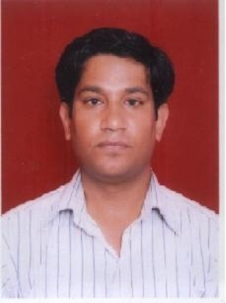

INDIVIDUAL Lab Instructor DATA SHEET
Name of the Lab Instructor |  | Rajender Singh Sirowa
Present Designation |  | Lab Technician
Email Id: rajendrasirowa@gmail.com
Contact Details: 9251039716

I. Particulars of Educational Qualification: (only completed)

Category | Name of the Degree | Specialization | Year of Passing | Name of the College | Name of the University
UG | B.A | History, Sociology | 2001 | S.S. Jain.Subodh Colloege | Rajasthan University
PG | M.A | History | 2004 | Rajasthan University | Rajasthan University
Diploma | DCA | Basic Computer | 2005 | Computer Art, Center | MD University
PG | Post Graduation in computer application | Computer | 2012 | CMJ University Meghalaya | CMJ University Meghalaya
MCA | Master in Computer application | Computer | 2016 | Jaipur National University, Jaipur | Jaipur National University, Jaipur

II. Academic Experience : 15 Year
III. Industrial Experience :

IV. Awards/Achievements :

VI. Research/Specialization :

VII. Course Taught :

